Name:
Course:
Date:

Show your work on a different sheet of paper.
Do not forget to check the mode on your calculator.
Fill (_._) in with (cos(x),sin(x))
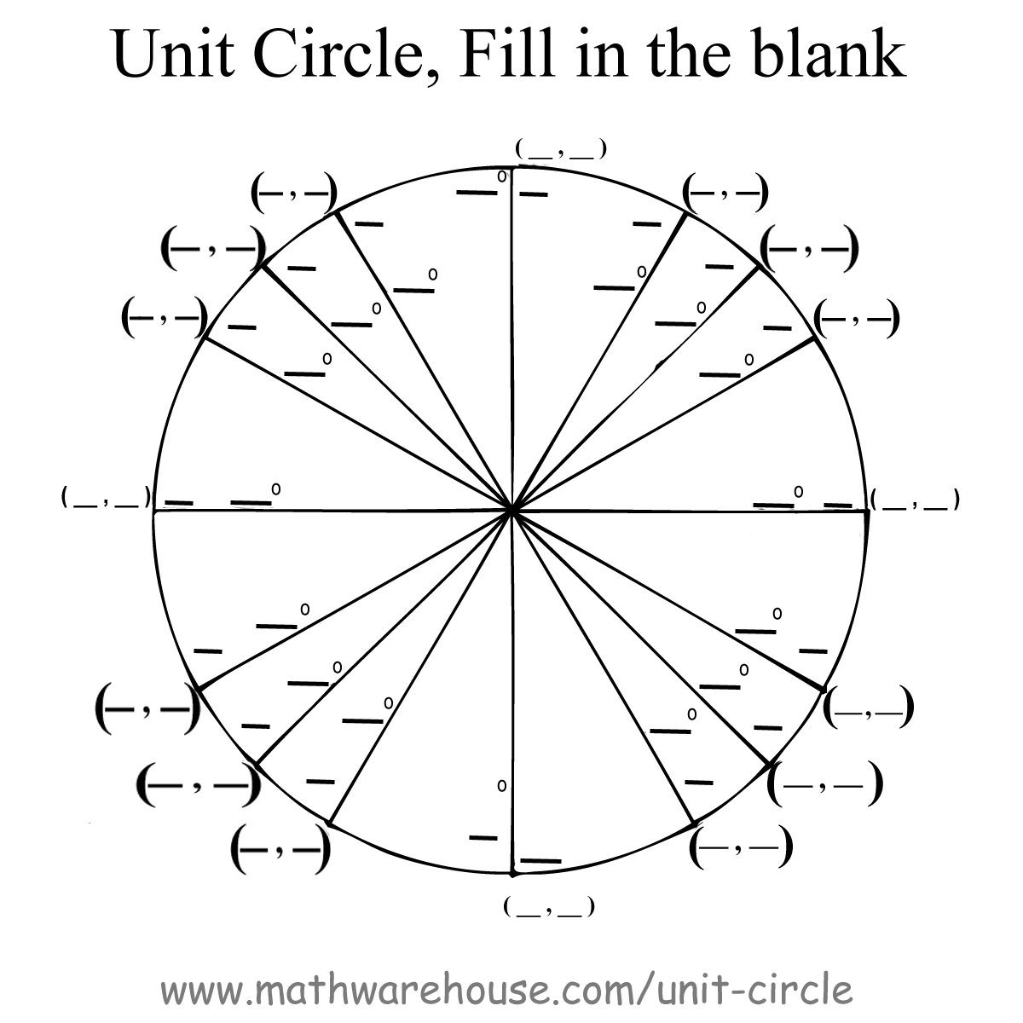

Take a string, measure the radius of each circle. Determine how many radii can go around each circle. Write the answer next to each circle.

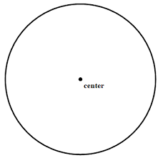
Type 2$π$ into your calculator. Is this close to your three measurements above?

Convert the following from radians into degrees:

- $\frac{2π}{5}$
- $\frac{π}{9}$
- $\frac{7π}{8}$

Convert following from degrees to radians:
- 33°
- 49°
- 68°
- 111°
- 285°
- 356°

Find the tangent of all of the angles shown in the unit circle above.

Write csc(x) in terms of cos(x).

Write sec(x) in terms of sin(x).

Write cot(x) in terms of tan(x).

Write tan(x) in terms of sin(x) and cos(x).

Graph y = sin(x) and y = cos(x) on the same axes. Do not use a graphing calculator or a computer.

On a new graph, manipulate y = sin(x) one step at a time in the following ways:
- 2sin(x)
- 2sin(x) + 1
- 2sin(0.5x)+1
- 2sin(0.5x-2)+1
Show all four steps individually on the same axes.

